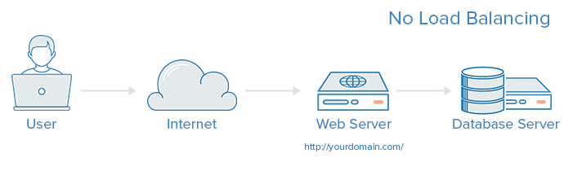

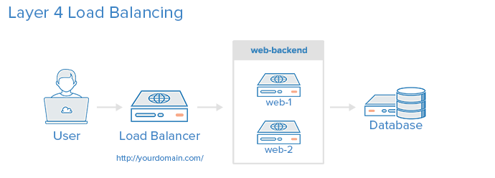

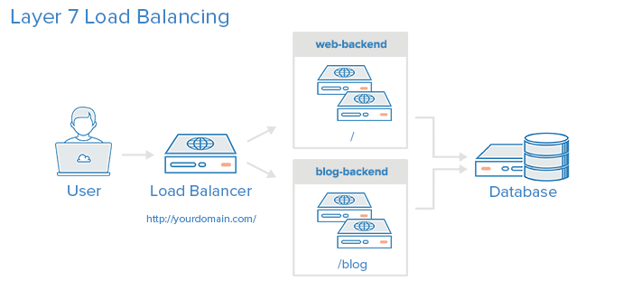



<https://www.digitalocean.com/community/tutorials/an-introduction-to-haproxy-and-load-balancing-concepts>